Sensory and motor pathways
Student’s Name
Institutional Affiliation

Sensory and motor pathways
Introduction
Millions of sensory neurons deliver information to the central nervous system all the time. Millions of motor neurons cause the body (muscle) to respond in a variety of ways. This article explores the sensory and the motor pathways in the body and addresses the patient’s question about why patients with strokes on the right side of the brain paralyze the left side of the body. The article also uses a diagram to illustrate the explanations.
Diagram showing Motor and sensory pathways

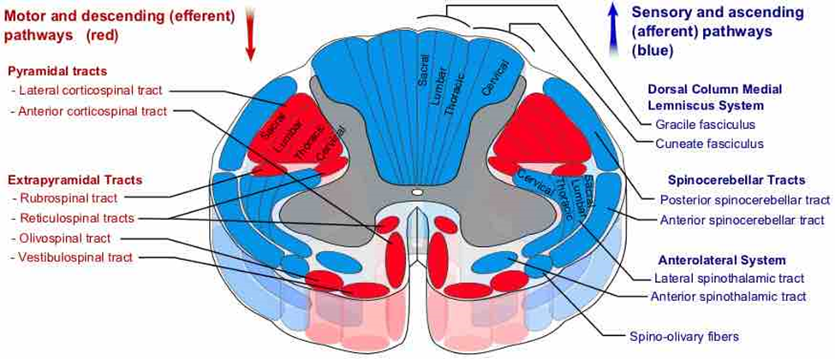
Sensory pathways (blue)
The somatic or the somatosensory system consists of neurons that make sensing touch, temperature, and position in space possible (Huang et al., 2015). The somatic sensory pathways carry information from the skin and muscles to the central nervous system. The sensory pathway from the receptors of the skin to the sensory area of the cerebrum basically follows three steps. There are three neurons involved in this pathway. The first-order neurons or the primary neurons go from the receptor-like the skin to the spinal cord. The cell body of the primary neuron is found in the dorsal root ganglion of a spinal nerve.
The second-order neurons (secondary neurons) carry the information to the cerebrum or thalamus. The neuron’s ascending axons cross or decussate to the opposite side of the spinal cord and travel up to the brain terminating either in the cerebrum or thalamus (Jones & Powell, 2014). Finally, the third-order (tertiary) neurons whose cell body is in the thalamus carries information to the sensory cortex of the cerebrum where the sensation becomes perception. In the sensory cortex, there is an uneven distribution of sensations. This creates a sensory homunculus which is a map of the sensory cortex.
Motor tracts
Motor tracts shown in red in the diagram carry signals from the brain to both the skeletal muscle and the smooth muscle such as those contained in glands. Motor commands are delivered by the somatic nervous system and the autonomic nervous system. The latter directs the activity of smooth muscles, glands, and cardiac muscle while the former directs the contraction of skeletal muscles. The system consists of upper and lower motor neurons. The connections between the motor cortex and motor neurons are made up of two pyramidal tracts namely the pyramidal system and the extrapyramidal system. The pyramidal system also called the corticospinal produces fine movements such as writing and playing music. The pathway contains direct connections that do not have synapses within the brain stem (Porter & Lemon, 2013).
Nerve fibers of this system originate in the cerebral cortex and then pass to the thalamus and medulla oblongata. Some fibers cross decussate in the medulla oblongata while others remain ipsilateral until they leave the spinal cord where they cross the midline of the body. The corticospinal tract is divided into the anterior and lateral corticospinal tracts. These two cross in the medulla oblongata which makes the right brain controls the left side of the body and the left brain controls the right side of the body. Extrapyramidal system, on the other hand, has synapses within the brain stem. These tracts do not run within the pyramids of the medulla oblongata but instead, run outside it. The extrapyramidal system causes involuntary movements and actions (DeLong & Wichmann, 2017).
Patient’s concern
Patients who have had strokes on the right side of the cerebrum have paralysis on the contralateral side of the body because movement and sensation for one side of the body are controlled by the opposite side of the brain (Brooks & Stoney, 2010). This means that if your stroke affected the right side of your brain, you will paralyze the left side the body and vice versa. This concept is underlain in the corticospinal tract which is divided into two tracts (lateral and anterior tracts) which cross the medulla oblongata making the right brain to control the left side of the body and the vice versa happens with the right cerebrum.
Conclusion
In conclusion, the pyramidal system as shown in the diagram is responsible for the complex situation surrounding the patient. The patient experiences pain in the left side of the body because the stroke affected the right side of the cerebrum. This is because the sensation for one side of the body is controlled by the opposite side of the cerebrum.

References
Brooks, V. B., & Stoney Jr, S. D. (2010). Motor mechanisms: the role of the pyramidal system in motor control.
DeLong, M. R., & Wichmann, T. (2017). Circuits and circuit disorders of the basal ganglia.
Huang, Y. Z., Edwards, M. J., Rounis, E., Bhatia, K. P., & Rothwell, J. C. (2015). Theta burst stimulation of the human motor cortex. .
Jones, E. G., & Powell, T. P. S. (2014). An anatomical study of converging sensory pathways within the cerebral cortex of the monkey.
Porter, R., & Lemon, R. (2013). Corticospinal function and voluntary movement (No. 45). Oxford University Press, USA.

